CPM Rental Agreement: Patient
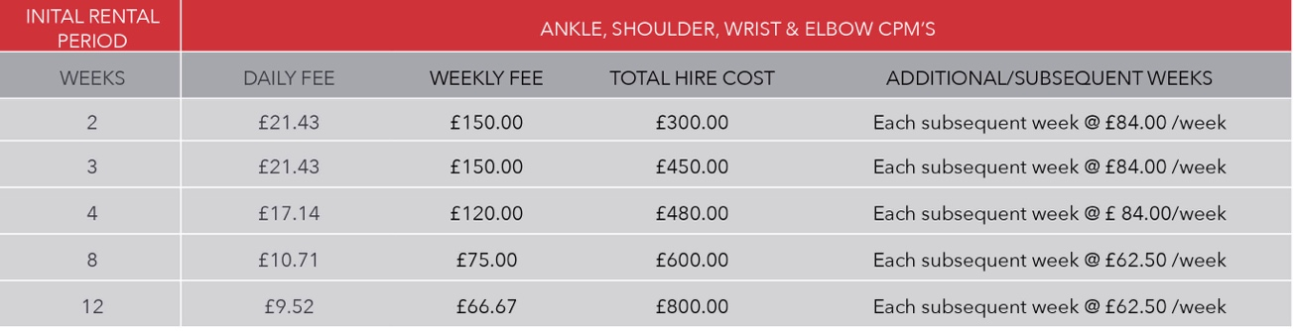
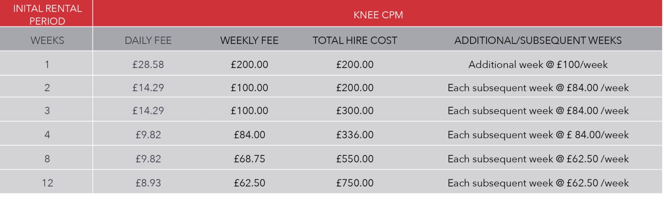

All prices include VAT, delivery and collection

Conditions of Rent
- Kinetec® CPMs are provided for rental on weekly tariffs only (not daily).
- The CPM must be used as directed by the medical professional (physician or therapist) including settings such as speed, force and range of motion.
- The CPM must be used in accordance with the manufacturer’s user instructions (provided).
- The CPM is the sole responsibility of the person renting the CPM for the duration of this agreement.
- The CPM is supplied for the use of the person renting it only and shall not be used with any other third party without written permission of Medfac UK.
- The CPM must be returned to Medfac UK within one week of the end of the rental period. The return is a free of charge service and should be arranged directly with Medfac UK. Failure to return the CPM within the stated time period will incur charges of one week’s rent for every week or part thereof extra to this agreement, until the CPM is received by Medfac UK.
- The CPM must be returned in the original packaging supplied. Please apply the labels supplied by Medfac UK and the carrier (at point of collection) to the outside of the packaging.
- Any costs associated with repair of the CPM due to damage, (accidental or otherwise), during the period of its hire will be borne by the person renting the equipment.
- If the CPM is not returned by the agreed date, in good working condition and in its original packaging, the person renting it may become liable for the full value of the CPM and any other costs involved.
- Medfac UK Ltd are covered by public liability insurance to £5m.

I hereby agree to the above Conditions of Rental:
Signed: |  | Date:
Print Name:
Delivery Address:
Telephone/Mobile:
Email:
Any other information (Including special delivery instructions)

